

Event: BeOne’s Brukinsa tablet (160 mg, film-coated) formulation granted EC approval
Impact: MEDIUM – EC approval of Brukinsa’s new film-coated tablet formulation (160 mg) will reinforce its leadership in the BTKi market by providing dosing flexibility and improved patient convenience
Competitor / Asset: Brukinsa (zanubrutinib, cBTKi)

BeOne announced Brukinsa's new film-coated tablet formulation (160 mg) received EC approval in all approved indications (CLL, FL, WM, MZL). Recommended dose of Brukinsa continues to be 320 mg daily, the 160 mg will allow patients to halve their daily pill intake from four pills to two pills. BeOne touted that the tablets will “advance treatment simplicity and convenience to meet patient needs across Europe.”

Please note that SmPC has not been updated yet.

Key Updates:
- The EC approval follows the positive CHMP opinion granted on Jun 25, 2025. Notably, the approval was granted ~58 days post CHMP opinion, consistent with traditional timelines (~67 days) but contrary to the recent trend of faster approvals (recent cases, such as Jaypirca and Columvi’s approval within ~30-40 days)
  - In the US, Brukinsa tablet formulation (160 mg with functional scoring) was granted FDA approval on Jun 11, 2025, with launch expected in Oct 2025
- The approval was based on the results from two single-dose Ph 1 BGB-3111-114 and BGB-3111-115 crossover studies in healthy subjects, comparing Brukinsa tablets vs capsules
  - Brukinsa AUC increased up to 17% and Cmax up to 79% following administration of Brukinsa tablets with a high-fat meal in healthy subjects (Sourced from US PI)
- Reduced pill burden (2 pills vs. 4 pills previously) and ease of administration
  - Recommended dose of Brukinsa continues to be 320 mg daily, the 160 mg will allow patients to halve their daily pill intake from four pills to two pills
  - Additionally, the tablets are smaller than capsules and have film coatings, which make them easier to swallow
- Highlighted simplicity and convenience of tablet
  - BeOne touted Brukinsa’s “broadest label of any BTK inhibitor in Europe” and emphasized that new film-coated formulation is designed to meet “the real-world needs of patients, the new Brukinsa tablet formulation aims to simplify treatment, reduce pill burden, and enhance ease of administration, reflecting our continuous focus on patient-centered innovation.”
- Transition from capsules to tablets
  - BeOne previously indicated will transition from capsules to tablets in ex-China regions during 2025 as part of their commitment to sustainability (e.g., reducing impact on the environment)
  - The tablet will decrease the bottle size by ~70% while reducing required temperature controls during shipment (leading to reduced energy needs, greenhouse gas emissions, and global transport costs)
CI Comments:
- Brukinsa’s tablet formulation and potential scoring may represent a significant differentiator vs. Calquence tablets
  - Brukinsa tablets being smaller and film-coated, offer improved ease of swallowing over the capsules
    - Primary intel (ASCO/EHA 2025) notes Brukinsa tablet will be 10 mm in length vs the 22 mm capsule; Acala tablet is 7.5 mm wide x 13 mm long
  - As the SmPC is not out yet and there is no company guidance on scoring of the tablet in EU, Brukinsa tablets in the US have functional scoring
    - Assuming a similar approach in EU, Brukinsa tablets are expected to offer superior convenience and dosing flexibility adding value for hepatic-impaired populations requiring dose adjustments
    - Calquence tablets on the other hand are non-scored and must not be altered, restricting patient-friendly administration
- Upcoming US/EU launch of the new film coated tablet to further strengthen sales momentum and reinforce Brukinsa’s strong market position
  - Brukinsa has led US revenue for two consecutive quarters in 2025, achieving a 20% QoQ increase compared to its in-class competitor
    - The upcoming launch of the tablet is expected to further strengthen its leadership position in the global market
  - Primary insights gathered at EHA 2025 highlighted Germany will be the first market launch, likely in Sept / Oct 2025 (free-market pricing), followed by a launch in Norway in Jan 2026
  - In the US, Brukinsa tablet formulation (160 mg with functional scoring) was granted FDA approval on Jun 11, 2025 with launch expected in Oct 2025
  - BeOne plans to have only tablet formulations ex-China (AZ has only tablets formulation in the US and both capsules and tablets in EU)

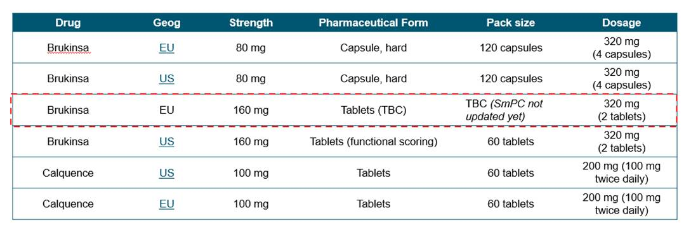

Background
- Study design and data of the Ph 1 study (Zanu Tablet vs. Capsules) for bioavailability studies:
  - Randomized, single-dose (160 mg), four-period fully replicated, crossover comparative bioavailability study conducted in healthy adult male and female volunteers under fasting conditions
  - Brukinsa tablets (1 x 160 mg) vs. Brukinsa capsules (2 x 80 mg)
  - Data from the N=57 subject study conducted under fasting conditions found that zanubrutinib tablets (1 x 160mg tablet) and zanubrutinib capsules (2 x 80mg) were pharmacokinetically similar by most measures investigated
  - Both AUC_{₀₋ₜ} and AUC_{0-∞}, and T_{max} were found to be within 3% difference
  - Peak drug exposure (C_{max}) was 21.8% higher in the tablet formulation, along with a reduced half-life (T_{1/2} 17% lower)
- Below is the bioavailability data from the Canada product monograph
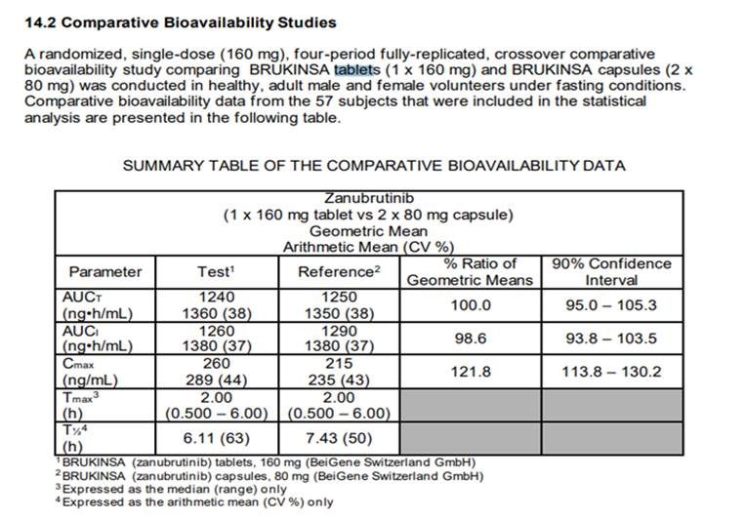

Source: Press Release

Disclaimer:
This document/email contains competitive intelligence collected via an approved competitive intelligence supplier working on behalf of AbbVie. We collect competitive intelligence consistent with industry standards and AbbVie policy. Not for field distribution. Please reach out to APEX/IMABI, Legal, or OEC teams with any questions

